Name

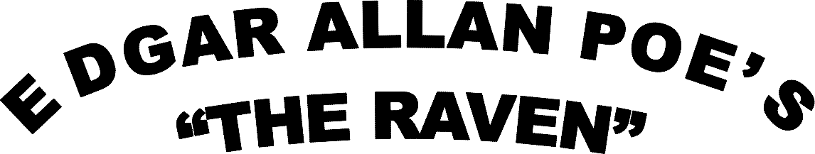

Poetic Elements

Once upon a midnight dreary, while I pondered weak and weary, While I nodded, nearly napping, suddenly there came a tapping,

In line (a) find the two words that are an example of internal rhyme and record them:

In line (b) find the three words that are an example of alliteration and record them:

“And the silken sad uncertain rustling of each purple curtain...” In this line find two words that are an example of assonance and record them:

Label each stanza with the following plot events: exposition, rising action, climax, falling action, or resolution.

Prophet!' said I, `thing of evil! - prophet still, if bird or devil! - On the pallid bust of Pallas just above my chamber door;
Whether tempter sent, or whether tempest tossed thee here ashore, Desolate yet all undaunted, on this desert land enchanted -
On this home by horror haunted - tell me truly, I implore -
Is there - is there balm in Gilead? - tell me - tell me, I implore!' Quoth the raven, `Nevermore.'

Once upon a midnight dreary, while I pondered weak and weary, Over many a quaint and curious volume of forgotten lore,
While I nodded, nearly napping, suddenly there came a tapping, As of some one gently rapping, rapping at my chamber door.
`'Tis some visitor,' I muttered, `tapping at my chamber door - Only this, and nothing more.'

Presently my heart grew stronger; hesitating then no longer,
`Sir,' said I, `or Madam, truly your forgiveness I implore;
But the fact is I was napping, and so gently you came rapping, And so faintly you came tapping, tapping at my chamber door,
That I scarce was sure I heard you' - here I opened wide the door; - Darkness there, and nothing more.

And the raven, never flitting, still is sitting, still is sitting On the pallid bust of Pallas just above my chamber door;
And his eyes have all the seeming of a demon's that is dreaming,
And the lamp-light o'er him streaming throws his shadow on the floor; And my soul from out that shadow that lies floating on the floor
Shall be lifted - nevermore!`

`Be that word our sign of parting, bird or fiend!' I shrieked upstarting -
`Get thee back into the tempest and the Night's Plutonian shore! Leave no black plume as a token of that lie thy soul hath spoken! Leave my loneliness unbroken! - quit the bust above my door!
Take thy beak from out my heart, and take thy form from off my door!' Quoth the raven, `Nevermore.'

What is the setting of “The Raven”? Include month and weather.

Explain the conflict in “The Raven.”

In what ways does the author create “mood” in the opening stanza?

Is there any indication that the narrator may have dreamt the entire episode?

What is he hoping the Raven can tell him?

Copy and identify one form of figurative language used in the poem:

Throughout the poem, many words are repeated (ex: chamber, sorrow, Nevermore, Lenore). Why does Poe do this? What type of effect does it have on the reader?

Put the events in “The Raven” in order by writing the numbers 1-6 on the lines provided.

The raven comes in and perches above the narrator’s door. The narrator yells at the raven to leave. The narrator whispers “Lenore” into the hallway. The narrator questions whether the bird is natural or supernatural. The narrator reads by the fire. The narrator hears something at the window and opens it.

Textual Analysis

Open here I flung the shutter, when, with many a flirt and flutter, In there stepped a stately raven of the saintly days of yore.
Not the least obeisance made he; not an instant stopped or stayed he; But, with mien of lord or lady, perched above my chamber door - Perched upon a bust of Pallas just above my chamber door -
Perched, and sat, and nothing more.

Explain what happens in the stanza above:

What word does the raven always use to answer the narrator’s questions?

Additional notes:

Questions I have now that we’ve finished “The Raven.”

