Social Studies 9

Chapter 7: Consumerism

Definition for consumerism: an economic theory that links prosperity to

consumer demand for goods and services, and that

makes consumer behaviour central to economic

decision making.

What does that mean?

What is anti-consumerism?

According to Wikipedia…

*It is a socio-political ideology opposed to* [*consumerism*](http://en.wikipedia.org/wiki/Consumerism)*, which discourages an ever-growing purchasing and consumption of material possessions. Anti-consumerist activists express concern over modern corporations or organizations that pursue solely economic goals at the expense of environmental, social, or ethical concerns*

What is ethical consumerism?

It is a type of [consumer activism](http://en.wikipedia.org/wiki/Consumer_activism) that is based on the concept of [dollar voting](http://en.wikipedia.org/wiki/Dollar_voting). It is practiced through 'positive buying' in that ethical products are favoured, or 'moral [boycott](http://en.wikipedia.org/wiki/Boycott)’ that is negative purchasing and company-based purchasing.

**What role should consumerism play in our society?**

Focus Question: What guides your behaviour as a consumer?

**Taste Test**

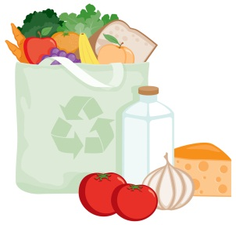You will participate in a blind taste test to determine which item you think is the best tasting.

Follow the teacher’s instructions, and fill out the chart honestly.

|  |  |  |  |
| --- | --- | --- | --- |
| Product | Which tastes better? | Which is the Brand Name? | Guess the price difference. |
|  |  |  |  |

MCj04399410000[1]

Discussion Questions:

1. Why do you choose certain products to wear, eat, or use?

______________________________________________________

1. Do you base decisions on brand names, quality, price, taste?

_____________________________________________________

1. When is cost a factor? ________________________________________
2. How does advertising affect our choices and purchases? _________________________________________________

___________________________________________________________

1. Do you consider the environmental consequences for certain purchases (a reusable water bottle or coffee cup)?

___________________________________________________________

**Identity** (pg 244 – 245)

List some consumer brand names that you are aware of and state what message is portrayed by this brand

Brand: ______________________

Message: ________________________________________________________________________________

Brand: ______________________

Message: ________________________________________________________________________________

Brand: ______________________

Message: ________________________________________________________________________________

How would you describe the way your identity shapes your buying habits?

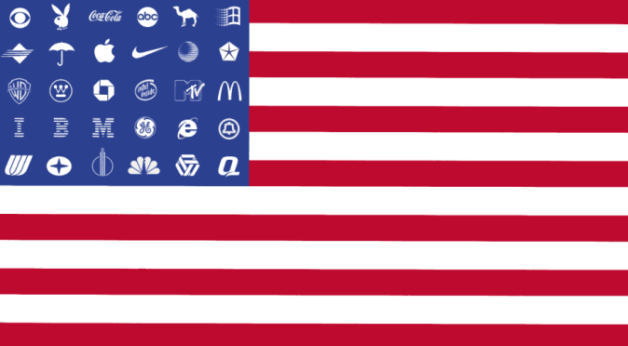

Provide a written response or draw a picture (see example)

**Health and Safety** (pg 248)

Do companies always have consumer’s health and safety as their top priority?

* Laws were developed to protect consumer health and safety.

In both Canada and the United States certain products require safety labels. What do you think the criteria for labeling should be? Identify four criteria.

1. ___________________________________________________________
2. ___________________________________________________________
3. ___________________________________________________________
4. ___________________________________________________________

Pick 2 products and complete the chart.

**Product Health/Safety Concern Why it should be labeled?** (What should the label tell the consumer).

_________ __________________ ________________________________________________

_________ __________________ ________________________________________________

Canada has banned some products that the United States has not. Some municipalities ban products others do not. Examples of this include smoking, use of transfats and plastic water bottles. Who should be responsible for consumer health and safety?

the government the consumer

How would you convince a person who disagrees with you?

*Here are some truly whacky health and safety labels.*

http://www.forbes.com/2011/02/23/dumbest-warning-labels-entrepreneurs-sales-marketing-warning-labels_slide_9.html

**Jobs** (pg 250 – 251)

Bangladesh clothing factory collapse (April 2013) <http://www.cbc.ca/news/world/story/2013/04/26/bangladesh-factory-building-safety.html>

Consumerism is the theory that the more consumers spend, the better it is for the economy. In what way does the flow chart on pg 250 support this theory?

**Environment** (pg 252 – 253)

Why might choosing to buy environmentally friendly products affect the quality of life for you and other people?

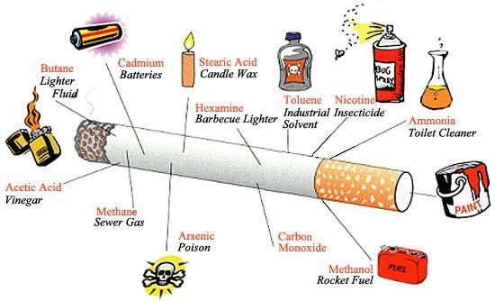

Social 9

Consumer Choices

Instructions: Use your textbook pages 257 – 263 to help complete the tasks below. Some

tasks need to be done using the internet so be prepared to do some of this

worksheet at home.

1. It may seem obvious, but explain how a person’s income affects their consumer choices.
2. Read the following passage.

Sometimes famous brands will repackage their product so that it can be sold at a cheaper price but under a different name. This occurs most commonly at the grocery store. For example, Del Monte has a few generic brand names that are sold at places like Wal-Mart for much cheaper than the Del Monte product but both brands are processed at the same plant. There is a generic brand of cut green beans in a can that is the exact same product as the Del Monte cut green beans in a can.

Why would a company like Del Monte do this?

Why do you think that people still buy brand names on items even though it can easily be found for a much cheaper price?

1. What is the definition of GDP?
2. What is the definition of GDP/per capita?   
   The one in the textbook is not enough… create a definition in your own words.
3. Again, it might be obvious but explain how a country’s GDP would affect the consumer choices of its citizens.
4. Now think about the Del Monte situation from Question 2. Can you ADD to your answer now that you know about GDP? **Why would Del Monte repackage its product in different countries?**
5. What is the definition of a boycott?
6. Summarize what happening in the Les Patriotes boycott in 1837.
7. Summarize the Daishowa boycott between 1991 and 1998.

**HOMEWORK -**

Ethical Consumer.com has a list of active boycotts on certain products. Here is the website. <http://www.ethicalconsumer.org/boycotts/boycottslist.aspx>. There is an interactive alphabet jump menu. Pick two (2) letters and summarize the name of company and/or the product that the website wants us to boycott and why.

|  |  |
| --- | --- |
| Product Company | Reasons for the Boycott |
| Ex: Starbuck’s | The Industrial Workers of the World and the US Organic Consumer Association call for a boycott of Starbuck’s because of their unethical treatment of Ethiopian coffee farmers and because of their rampant tax evasion. |
|  |  |
|  |  |

1. Do you think that boycotts work? EXPLAIN!! (2 marks)
2. Have you made any consumer choices based on your ethical, religious, philosophical beliefs? Explain your choice. If you have not in the past, explain a consumer choice that YOU would make in the interest of ethical, religious or philosophical beliefs? (3 marks)